RAJALAKSHMI ENGINEERING COLLEGE

RAJALAKSHMINAGAR, THANDALAM – 602 105



CB23F35 LOW-CODE APPLICATION DEVELOPMENT USING ZOHO CREATOR
LABORATORY NOTEBOOK

NAME: DHANIGIVELA.B

YEAR/ BRANCH / SECTION: III/AIML/C

REGISTER NO. :241501042

SEMESTER: V

ACADEMIC YEAR: 2026 - 2027


RAJALAKSHMI ENGINEERING COLLEGE (AUTONOMOUS)
RAJALAKSHMI NAGAR, THANDALAM 602 105 BONAFIDE CERTIFICATE

NAME REGISTER NO.

ACADEMIC YEAR2026-27 SEMESTER- V BRANCH: B.Tech - AIML

This Certification is the Bonafide record of work done by the above student in the CB23F35 Low Code Application Development Using Zoho Creator Laboratory during the year 2026 2027.

Signature of Faculty -in Charge

Submitted for the Practical Examination held on

Internal Examiner External Examiner
INDEX

EXP. NO | Date | Title | QR | Signature
1 | 17|07|26 | Comparative study of low-code development versus traditional application development approaches. | 
2 | 24|07|26 | Setting up a Zoho Creator account and exploring the platform architecture and interface. | 
3 | 31|07|26 | Survey report on emerging trends in low-code application development. | 
4 | 01|08|26 | Data modelling and form design for a business application in Zoho Creator. | 
5 | 05|08|26 | Building reports, dashboards, and custom pages (UI Builder) for the application. | 
6 | 08|08|26 | Automating business processes using Deluge scripting and workflows, with application  testing and debugging. | 
7 | 14|08|26 | Integrating a Zoho Creator application with  another Zoho service using connections and APIs. | 
8 | 22|08|26 | Configuring user management and role-based access control (RBAC) in a Zoho Creator  application. | 

9 | 25|08|26 | Exploring AI-assisted features and built-in analytics (Zia) in Zoho Creator. | 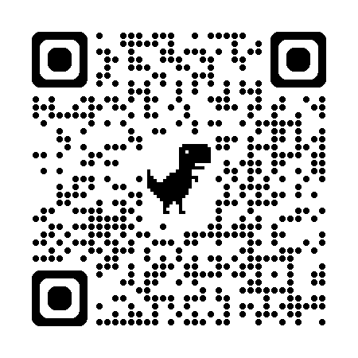
10 | 27|08|26 | Applying performance optimization techniques (indexing, subforms, query tuning) to a Zoho  Creator application. | 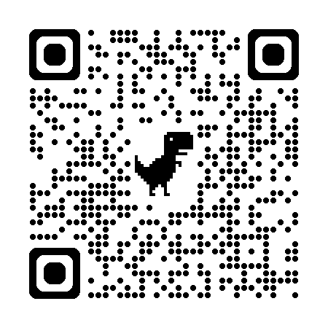
11 | 11|09|26 | Deploying a Zoho Creator application from development to production environment. | 
12 | 18|09|26 | Implementing security features and governance  / administration practices in Zoho Creator. | 
13 | 22|09|26 | Case study on the limitations of low-code  platforms for a complex enterprise use case. | 
14 | 06|09|26 | Exploring pro-code extension of a Zoho Creator application using Zoho Catalyst / custom  functions. | 
15 | 05|10|26 | Report and presentation on career pathways and the future of low-code development. | 
16 | 10|10|26 | Project

